The scripts was written with the intention of making the process of Quoting easier. This is that a rough support and rough price was to be quickly output. The input being a client part files and the output being the finished statistics CSV (build time, support volume, part volume and outbox volume of the tray).
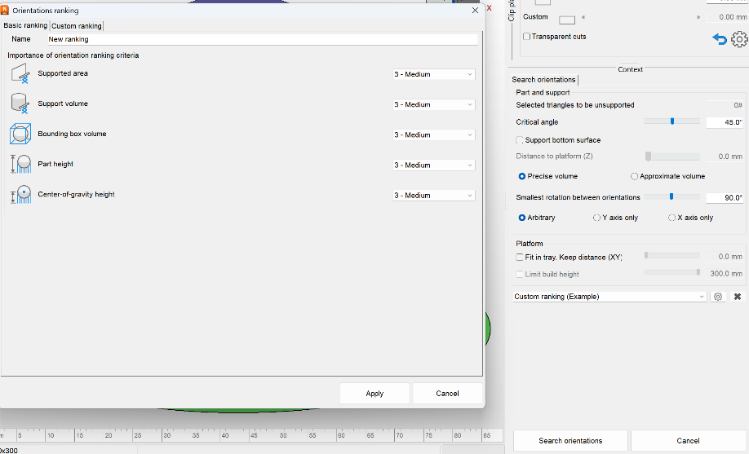
The orientation and the support addition is left to be done by the program, the employee and the support scripts. This is because there are heavy employee choices involved and the process of automatic orientation was a extremely difficult thing to program(Help | PartOrienter | Autodesk). And the part orientator in the Desktop Enviroment gives multiple options for ease of choice (I hated trying to debug the diagnoses scripts of the orientator). The internal part orientator can be given a custom weighting for the following parameters: 'outbox_volume', 'part_height', 'support_area', 'support_volume', and 'center_of_gravity_height'. It is accessed and edited in the Orientate editing environment:

It is important to note that for the custom machine there is a file No_Build that needs to be accessed via a file path everytime a new machine is openend.
This process was done with three main scripts, the importer script, the duplicate and arrange script, and the CSV exporter scripts. But first, notes about scripts and general Netfabb scripting
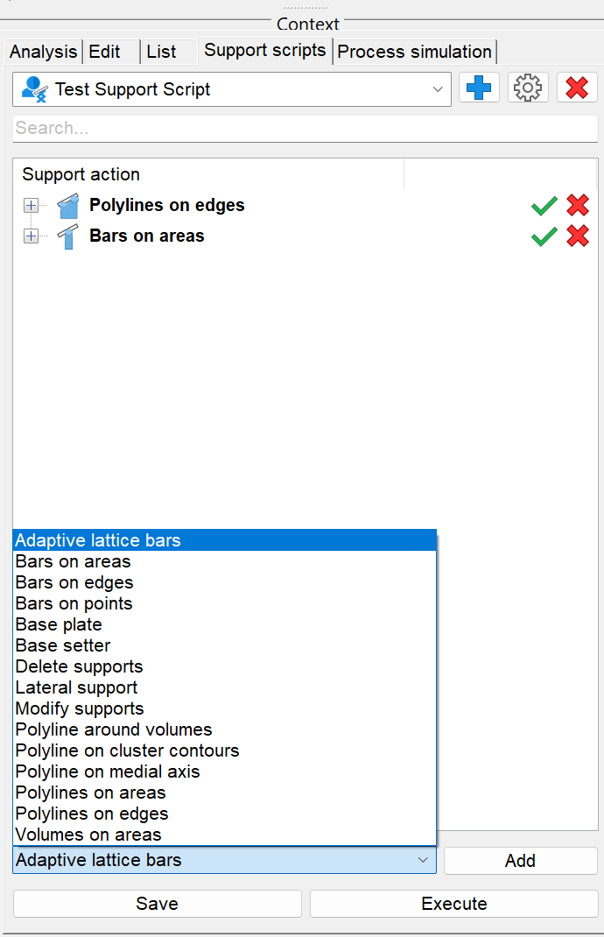
- Lua scripts and .support scripts are both called scripts but they are completely different. The .support scripts are a XML format where they detect and add supports for a part. There are also XML format for scripts, but they don’t detect where to put the parts, they are just settings for supports.
- For configuration of the .support scripts:
  - Help | Support action options reference | Autodesk
  - Inside the support editing workspace

- In scripting, the .support file can be used in the [support = mesh:createsupport(xmlfilename:String)] command
  - Help | Supports | Autodesk
- The most helpful place to search for functions are below
  - Help | Autodesk
- The one Netfabb instance can have multiple trays that are each custom, when they are assigned with a machine then they can give estimates and are called workspaces.
- All the scripts ask for a folder path where to insert the log file or to do things in.
- General functions and their syntax:
  - Help | System and file functions | Autodesk
Then about the specific scripts:

Importing Tool
Goal: To batch import the files into a custom machine environment.
Method:
Given a folder path and it just loops through and finds all files with a .stl, .3mf or other 3D file extension (doesn’t contain .step files). And then given a machine name it searches for the machine in the Netfabb environment and then opens new workspaces with each part in (highlighted because it took me a day to find out that there is a difference between a tray and workspace, AI didn’t help at all!!). And then it looks at the position, and centers the part based on the workspace/tray dimensions.

Duplicate and Arrange
Goal: To fill 60% of the build volume with the given part for quotation
Method: In the script there are two settings variables:
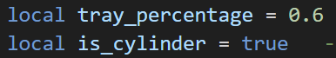
Tray_percentage sets the amount multiplied by the tray’s area to find the area to fill. And then cylinder determines whether to use the rectangular co-ordinate area formula or the cicle area formula.
The script loops through each of the tray/workspaces and looks at the one mesh inside, calculates the (tray area)*(tray_percentage) / part area.
Part area can be calculated either with the shadow area or the outbox area. Both methods are in the code, one is just commented out.
The script saves the 3mf with editable supports to a file named [partname]_3mf with the 3mfExporter (Help | 3mfExporter | Autodesk)
In order to duplicate with supports it does a kind of complex round path: It exports the part as a 3mf but with the support and part as two separate meshes (in the same file), and then it imports this with the 3mfImporter (which gets the two meshes names in the same file), and then it sets the support mesh as the support to the other mesh in the file. It does this the amount of times that is calculated to fill tray_percentage.
It is important to note that the luamesh:dupe() function does not duplicate the supports because the Luamesh (Help | LUATrayMesh | Autodesk) loses all supports. Supports are saved as a dependency of the original mesh.
I tried the Monte Carlo, Trueshape and Scanline packer and the Scanline seemed to be the only one that worked. Monte Carlo packed in 3D, and Trueshape ignored the no-build areas.

CSV Exporter
The following data can easily be calculated in script: Part name, Part Volume, Bounding Box Volume, and Support Volume. But it is almost impossible to get the build volume via a script. That is because the module that calculates it is a completely different basis that what the scripts work on. The outline of how the estimate is calculated can be found here: Help | Build-Time Estimation | Autodesk. There are a possible method via creating a custom template that is exported and then back imported into the script to extract the time. But this will be difficult and time consuming to program (trust me, I spent a literal day just getting to the point that I found out how hard it is)
The Builtime estimation function parameters can be edited: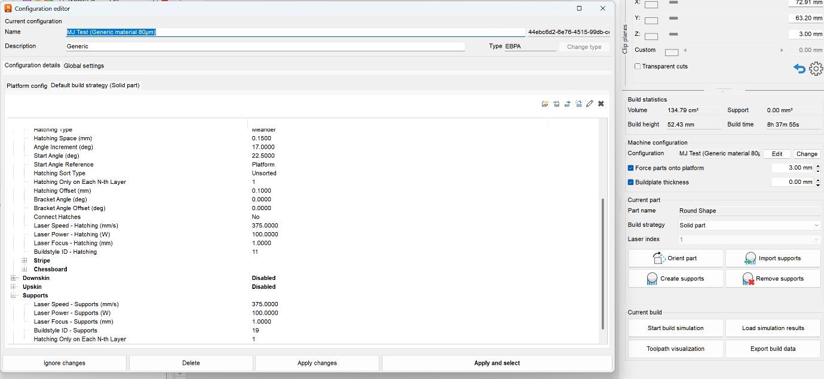
Update: I did in fact try the report generation, with a custom template where in the Build Time was. NETFABB_ENGINE_BUILDTIME, but the Lua Scripts didn’t seem to be able to generate a script that was able to see the build time.
But I might implement that later.

